# C3- S2 – PRACTICE



**EXERCICE 1**

A person has a **name** and a **year of birth**:

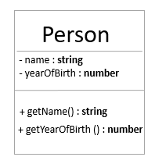

A calendar is in charge of **computing the age of a given person**

* We need only 1 instance of the calendar
* A calendar contains the CURRENT YEAR (ex : now it’s 2023)

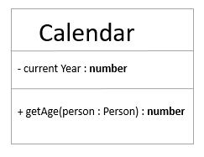

**Q1 -** Create the model, following the public/private visibilities of attributes and methods

**Q2 -** Code the method to compute the age of a person

**Q3 -** Test your model by creating **different person** and **1 unique calendar**

**EXERCICE 2**

* Open the **SCHOOL.TS file**

**Q1 -** Create the UML diagram corresponding to the classes and their relations ships

* + Don’t forget the visibilities (public / private)
  + Don’t forget the multiplicities (1, 0/1 etc...)
  + Write your UML diagram using the **TEMPLATE.PPTX** file provided

**Q2 -** Create a MAIN.TS file **to test your SCHOOL MODEL**:

* + Create 2 schools, 2 classrooms, 4 students

**EXERCICE 3 – THE DOM**

We want to represent the tree of the DOM elements, related to an HTML page

For example this page:

<html>

<head>

<title>

</head>

<body>

<a>

<h1>

<body>

</html>

Can be represented using this tree:

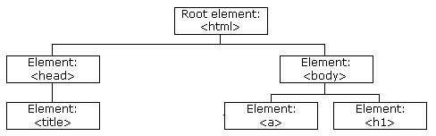

Every element is an object DomElement:

* The element can have a parent or not (is not, the element is a **root**)
* The element can have children or not (is not, the element is a **leave**)

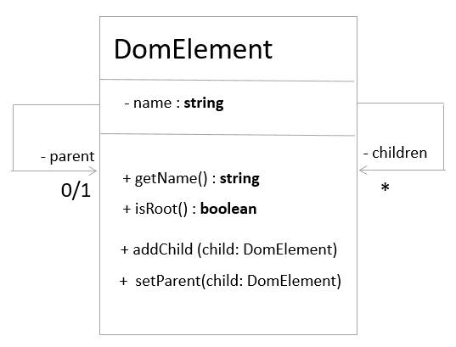

**Q1 -** Create the model, following the public/private visibilities of attributes and methods

**Q2 -** Test your model: create the node object which correspond to the following tree:

